**Creating Microservices for account and loan**

**1.Creating Microservice for account**

**Create Maven Project:**

1. Open STS -> File -> New -> Spring Starter Project
2. Enter like this in spring initializer.
   * **Name**: account
   * **Group**: com.cognizant
   * **Artifact**: account
   * **Type**: Maven
   * **Packaging**: Jar
   * **Java Version**: 8 or 11
3. Click **Next**
4. Select dependencies:
   * Spring Boot DevTools (from Developer Tools)
   * Spring Web (from Web)
5. Click **Finish**

**Add Controller:**

Create new class by right-click on com.cognizant.account and then New the Class then Name it AccountController.

package com.cognizant.account;

import org.springframework.web.bind.annotation.*;

import java.util.Map;

@RestController

@RequestMapping("/accounts")

public class AccountController {

@GetMapping("/{number}")

public Map<String, Object> getAccountDetails(@PathVariable String number) {

return Map.of(

"number", number,

"type", "savings",

"balance", 234343

);

}

}

**Run and Test:**

* Right-click on the AccountApplication.java and click Run As and Spring Boot App
* Open browser/Postman:  
  <http://localhost:8080/accounts/00987987973432>

**OUTPUT:**

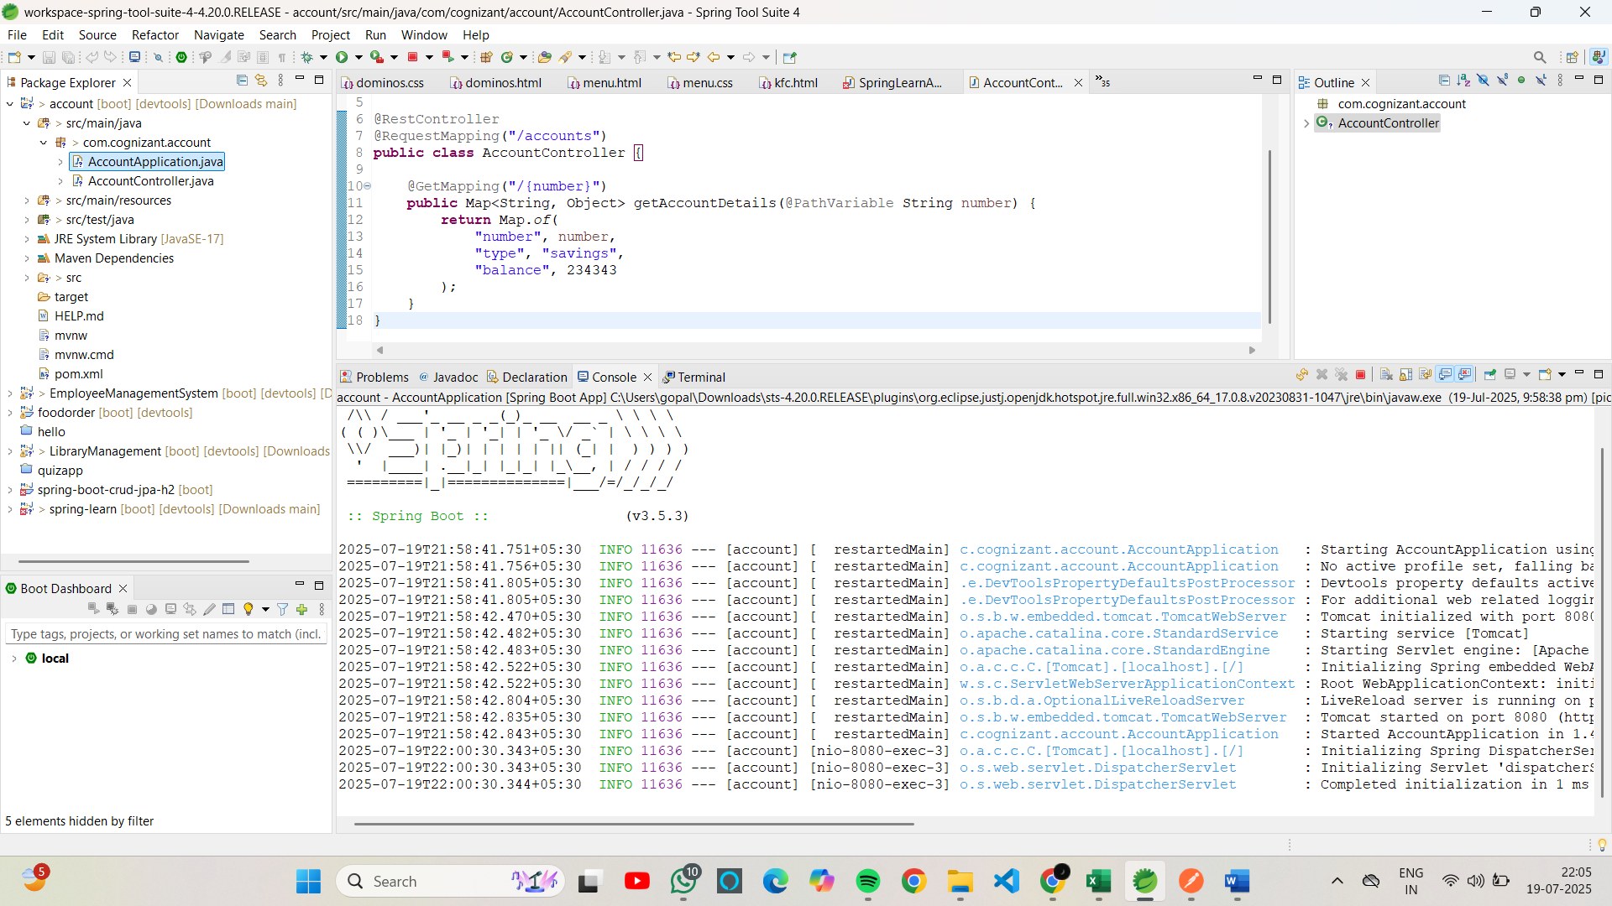

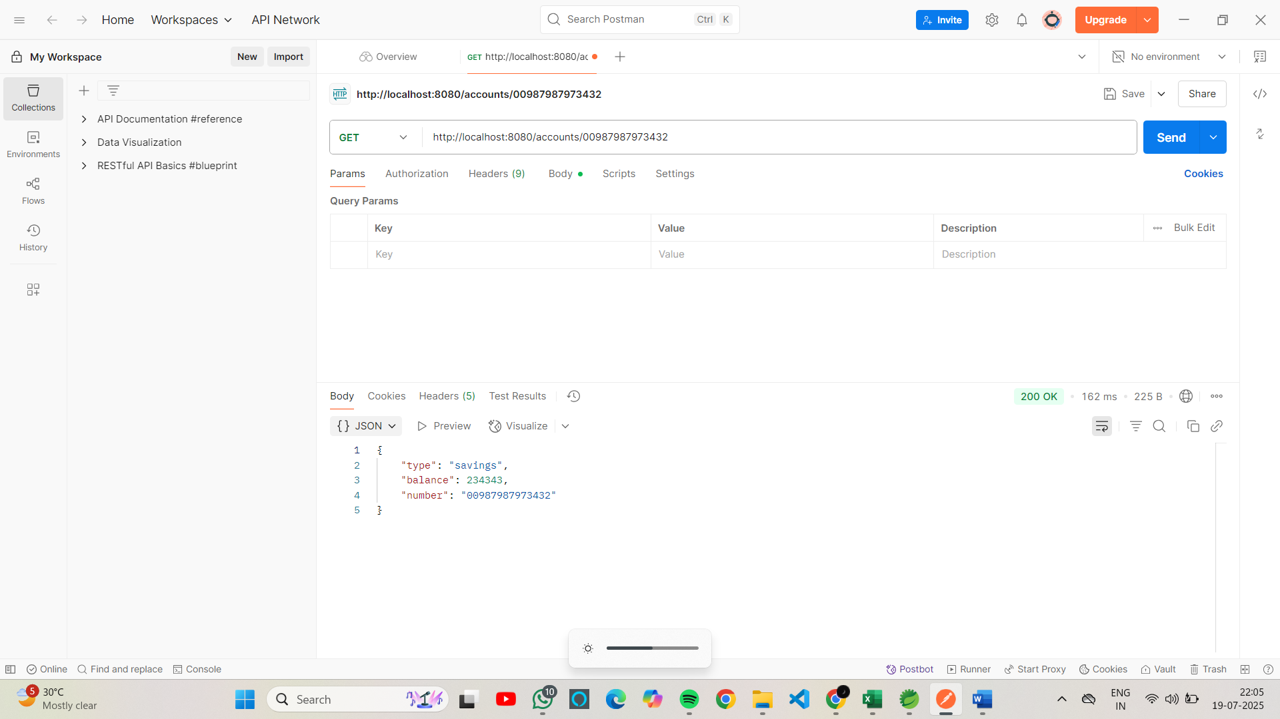

**2.Create microservice for loan**

**Create New Project:**

Enter like this in spring initializer

* + Name: loan
  + Group: com.cognizant
  + Artifact: loan

Select dependencies:

* + Spring Boot DevTools
  + Spring Web

Click Finish

Open src/main/resources/application.properties and add

server.port=8081 or any other port as you wish.

**Add Controller:**

Right-click on com.cognizant.loan create a LoanController class

package com.cognizant.loan;

import org.springframework.web.bind.annotation.*;

import java.util.Map;

@RestController

@RequestMapping("/loans")

public class LoanController {

@GetMapping("/{number}")

public Map<String, Object> getLoanDetails(@PathVariable String number) {

return Map.of(

"number", number,

"type", "car",

"loan", 400000,

"emi", 3258,

"tenure", 18

);

}

}

**Run and Test:**

* Right-click LoanApplication.java and then Run As Spring Boot App
* Open browser/Postman:  
  http://localhost:8081/loans/H00987987972342

**OUTPUT:**



